Sample Data
21
Brand: | *K2 | *Atomic | *Roxy | *K2 | *Atomic | *Roxy | *K2 | *DC | *Burton
Type: | Boots | Boots | Boots | Snowboard | Snowboard | Snowboard | Snowboard | Snowboard | Snowboard
Barcode:
Size: | 7 | 9.5 | 8 | 136 | 147 | 157 | 136 | 162 | 167
Price: | 174.95 | 68.95 | 89.95 | 25.00 | 25.00 | 25.00 | 289.90 | 228.00 | 290.95
RentSale: | S | S | S | R | R | R | S | S | S

Test For | Input | Expected | Output
Buying | Brand: K2  Type: Snowboard  Barcode:  Size: 136  Price: 25.00  RentSale: R  Status: Available | K2  Snowboard  **********************************  136  25.00  R  Available | K2  Snowboard  251b7406-531b-468e-a1c2-4b83b561d527136  136  25.00  R  Available  (In text file, the information has many spaces between and is on one line that is too long to copy here)
Selling | Barcode: 8a326400-c575-46d5-a51a-3a8b2612eb0a | Items.dat  -Item gone  Records.dat  -Item appended | 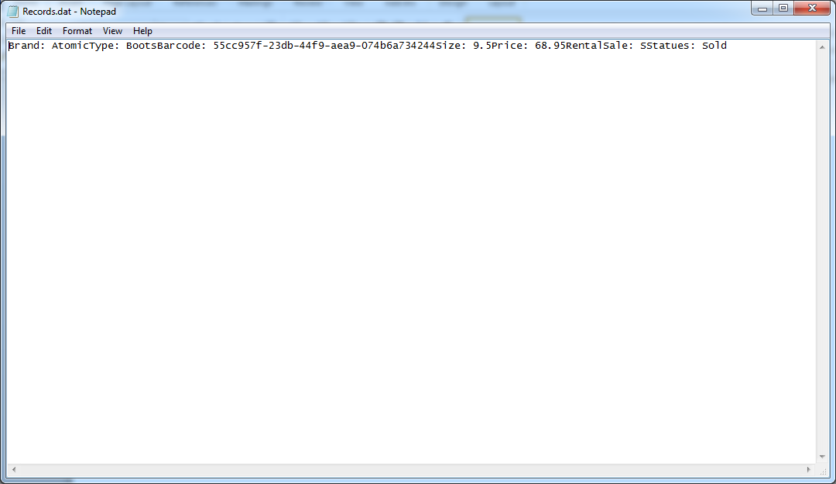
Renting | Barcode: 251b7406-531b-468e-a1c2-4b83b561d527136 | Item  Status: Rented Out | 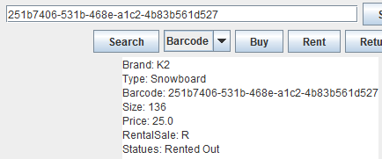
Searching | Type: Snowboard - with Snowboards | Brand: K2  Type: Snowboard  Barcode:  Size: 136  Price: 25.00  RentSale: R  Status: Available | 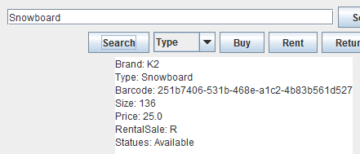  22
Searching | Brand: K2 – with K2’s | Brand: K2  Type: Snowboard  Barcode:  Size: 136  Price: 25.00  RentSale: R  Status: Available | 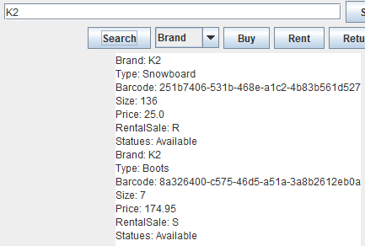
Searching | Type: Snowboard – without Snowboards | No Items Found | 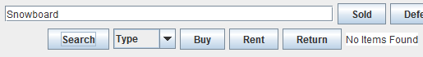
Displaying | All – with items in inventory | Brand: K2  Type: Snowboard  Barcode:  Size: 136  Price: 25.00  RentSale: R  Status: Available | 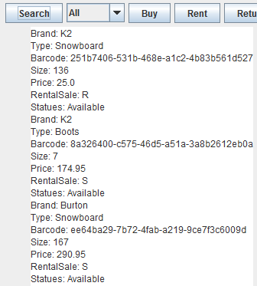  23
Displaying | All – without items in inventory | No Items in Inventory | 